AWS Web Application Firewall (WAF)

Create a VPC , two different subnets in different zone and create a route table and   
connect igw, and create a EC2 and install apache, make sure security group inbound   
rule allows traffic for port 80

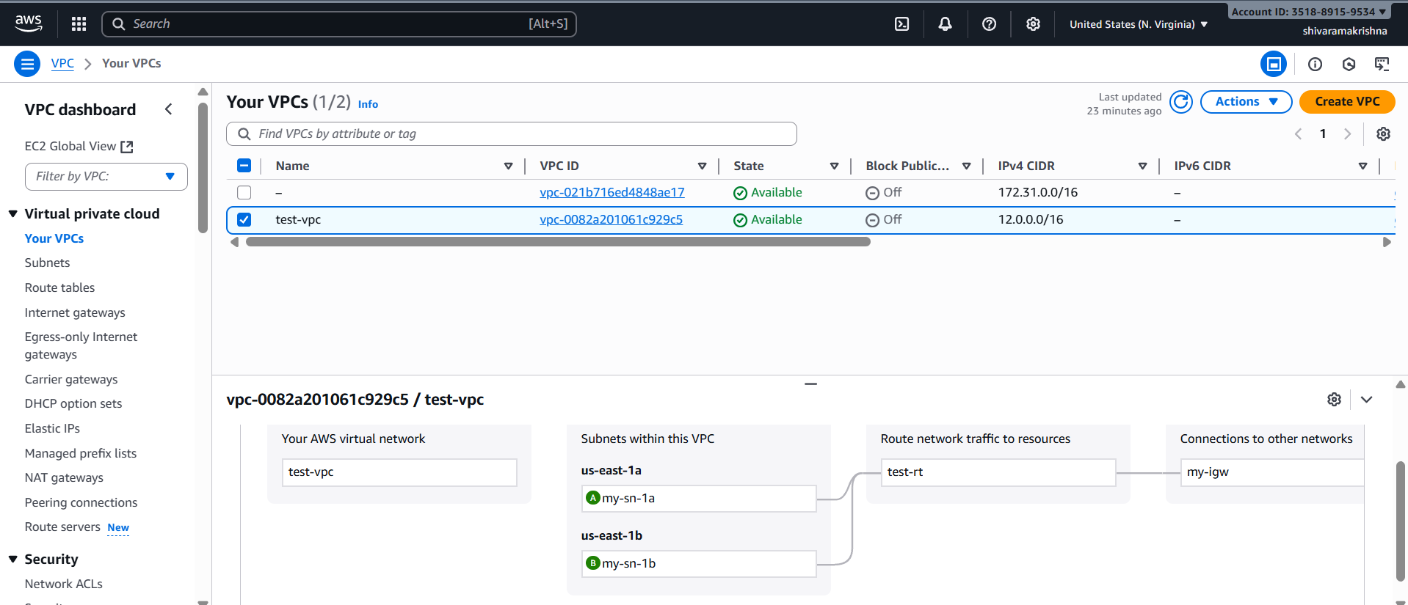

Created a target group by adding instance and create a application load balancer with   
listener http port and attached the group

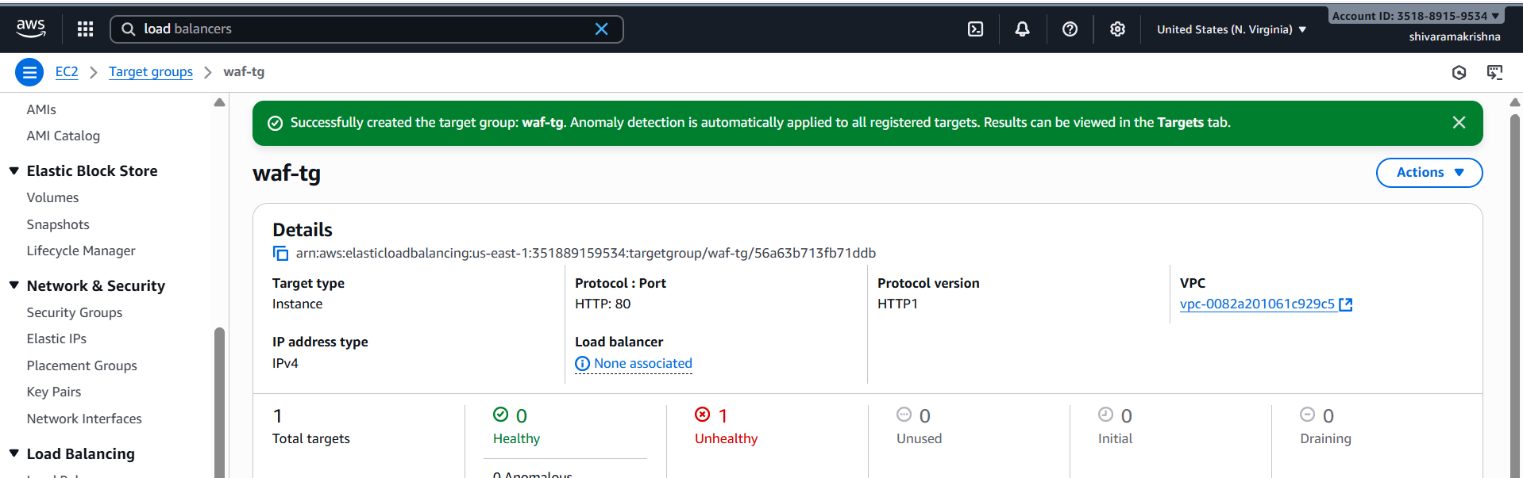

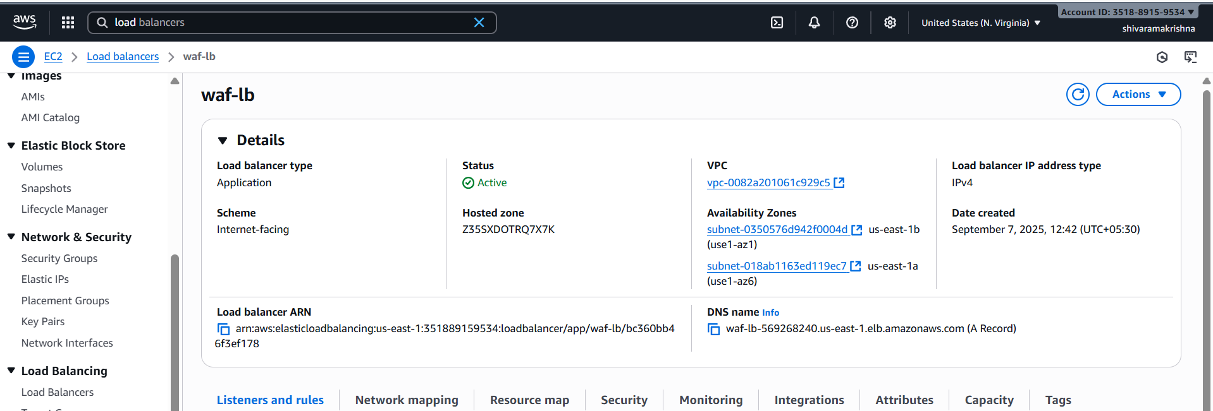

Go to AWS WAF → IP SETS added my laptop for block.

Now created web application firewall and add the rule with above ip set

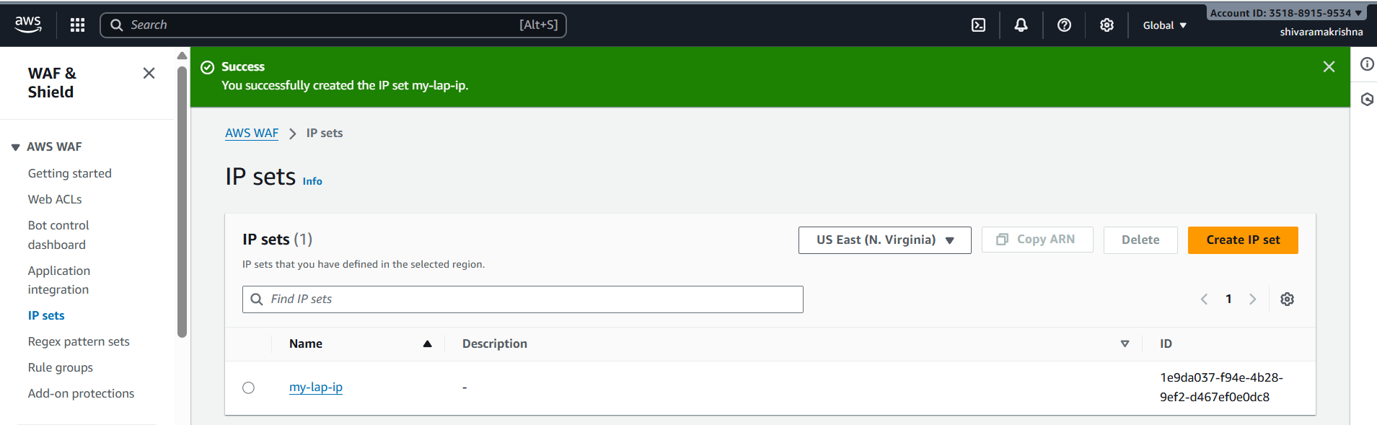

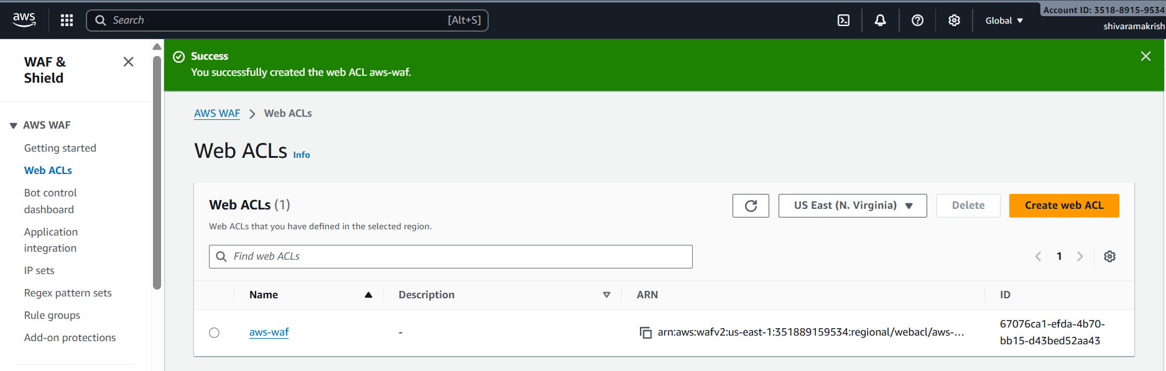

Now copy the dns name and check in url

You will blocked

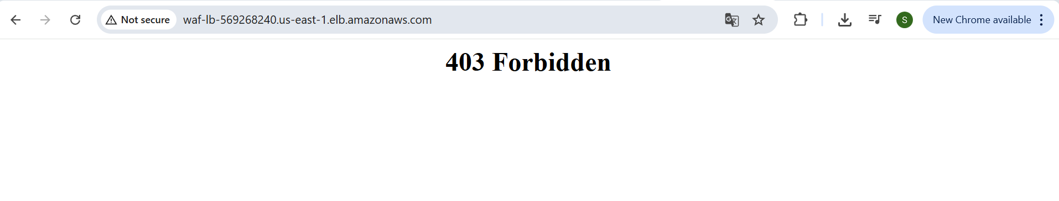

Now in web acl edit the rule as allow you will get this

Then its redirected to apache page

